We have completed some upgrades to our App - It's a look and feel upgrade only.
The same Member ID, password, memorable word and verification steps still apply, so there's nothing for members to set up or learn.
As a user, you should notice
Clearer screens with less clutter and friendlier language
Easier to read on mobile, with bigger, more accessible buttons

The same trusted security checks, now explained more simply
No new steps, no password resets, no re-registration required

So, what has changed and what has stayed the same

Changing | Staying the same
Fresh colours, spacing and typography | Login credentials (Member ID + password)
Simplified screen layouts | OTP / two-factor verification via app or SMS

Warmer, plain-English wording | Password reset flow (Member ID + DOB + memorable word)
Redesigned linked-device notice | Forgot username flow (email look-up)
 | Security messaging (e.g. never share an OTP/PIN)

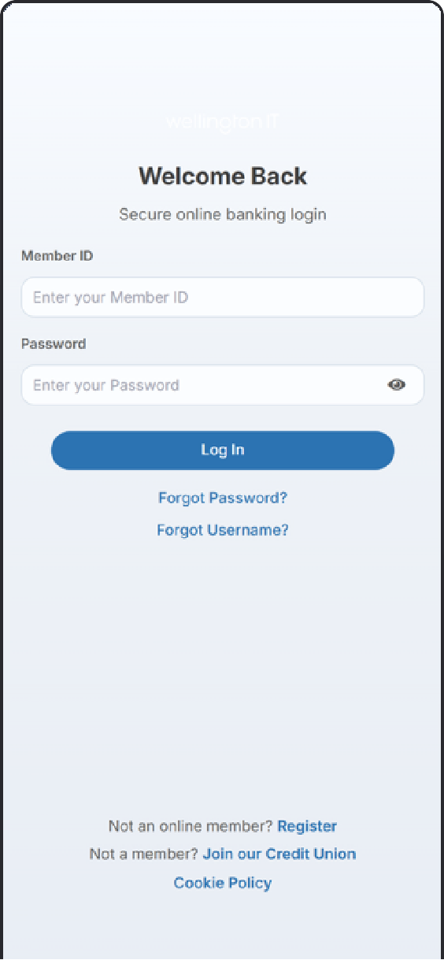
Walk- through the screens

Login screen: "Welcome Back"

Member ID and password fields, with a show/hide toggle on the password field. The primary action is Log In, with Forgot Password? and Forgot Username? links underneath, plus registration and join links in the footer.

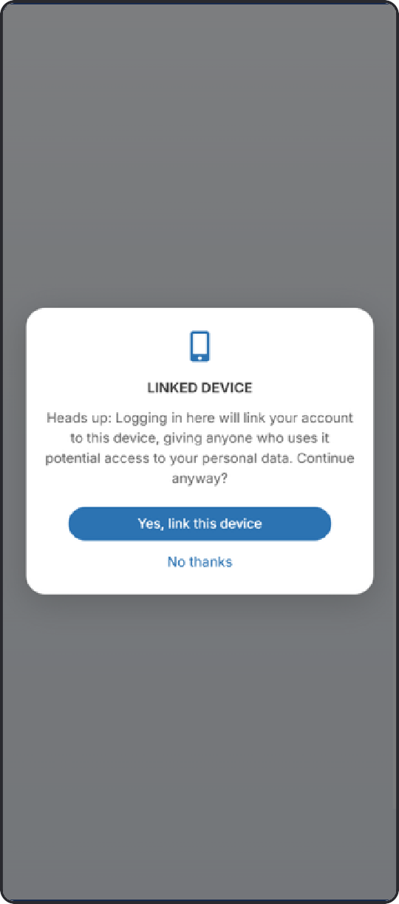
Linked device notice

This is shown the first time a member logs in on a new device, so they can confirm they're happy to link their account to it. This protection already existed. It's simply presented more clearly now.

Identity verification (OTP)

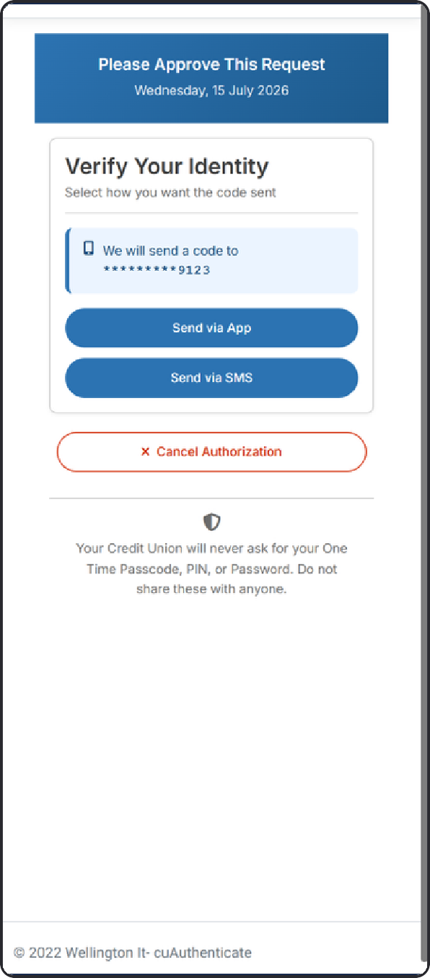

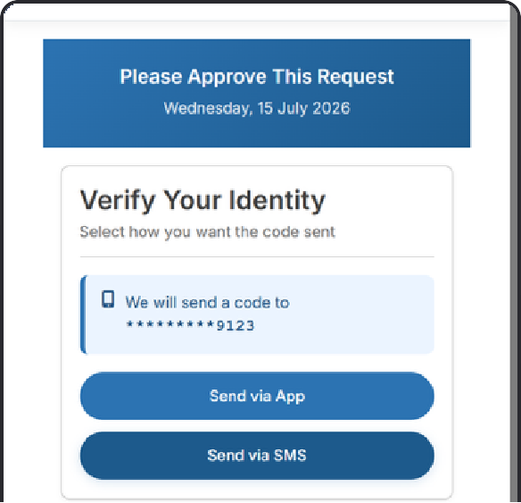
Verify Your Identity: choose how to receive your code

Verify Your Identity: enter your code and approve

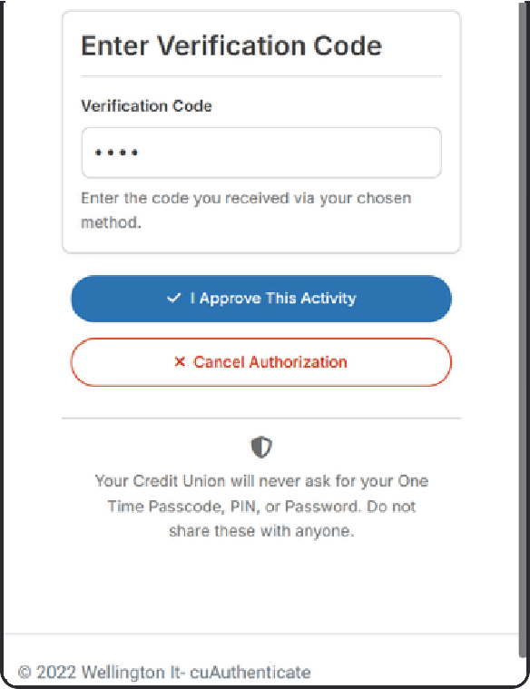

Members choose to receive their one-time code by app or SMS, then enter it to approve the activity. A persistent reminder tells members the credit union will never ask for their OTP, PIN or password.

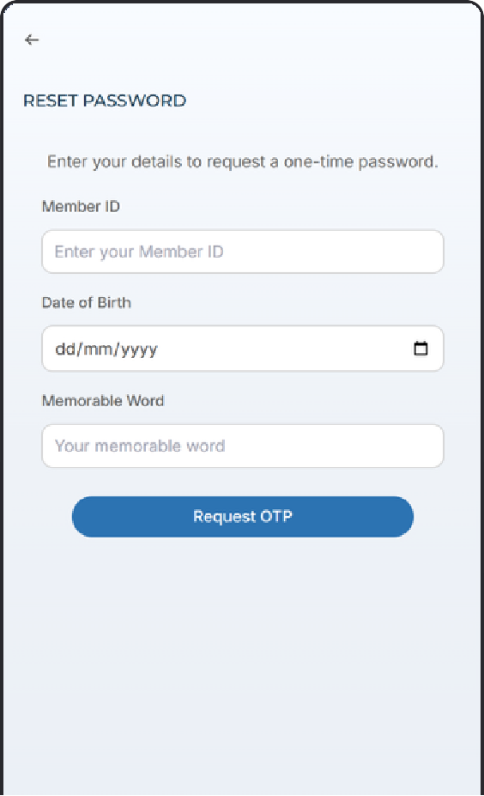
Reset password

Members confirm their identity with Member ID, date of birth and memorable word, then request an OTP to continue.

Forgot Username

Members enter their registered email address and receive a username reminder.

