Accessibility Statement

Tullamore Credit Union (TCU) is committed to making its website accessible, in accordance with European Union (Accessibility Requirements of Products and Services) Regulations 2023.
This accessibility statement applies to https://www.tullamorecu.ie/ *
*It does not apply to other content or websites published on any of its subdomains. These websites and their content will have their own specific accessibility statement.
This website is designed to comply with the technical standard for websites and mobile apps, EN 301 549 v.3.2.1. This closely follows level ‘AA’ of the Web Content Accessibility Guidelines 2.2 level AA.

Compliance Status
This website is compliant with technical standard EN 301 549 v.3.2.1 and the Web Content Accessibility Guidelines 2.2 level AA. See ‘Non-accessible content’ for more details.
TCU is committed to providing a website that is accessible to the widest possible audience, regardless of technology or ability.
We are currently working with Vially and Vision Ireland to ensure we meet accessibility standards. We are continually improving the user experience for everyone and adhering to the required accessibility standards.
The Web Content Accessibility Guidelines (WCAG 2.2) defines requirements for designers and developers to improve accessibility for people with disabilities.

Preparation of this Accessibility Statement
The Statement is based on a combination of manual and automated accessibility testing, using multiple platforms;
- Windows (JAWS, NVDA),
- Mac (VoiceOver),
- iOS (VoiceOver) and Android (TalkBack) and their native accessibility tools.
A detailed issue log was created to measure against WCAG 2.2 standards. These issues were presented to the development team who are amending these issues and bringing the website in to WCAG 2.2 AA compliance.
This statement was created by Vially in May 2026.
The statement was last reviewed in May 2026.

Feedback and Contact Information
We welcome feedback on the accessibility of this website. If you have any comments or find any problems not listed on this page, please contact [client to enter email]

Compatibility with browsers and assistive technology
This website is designed to be compatible with the following most used assistive technologies:
The latest version of Google Chrome, Microsoft Edge and Apple Safari browsers;
In combination with the latest versions of NVDA, VoiceOver and TalkBack.

Technical specifications
The accessibility of this website relies on the following technologies to work with the particular combination of web browser and any assistive technologies or plugins installed on your computer:
- HTML
- WAI-ARIA
- CSS
- JavaScript

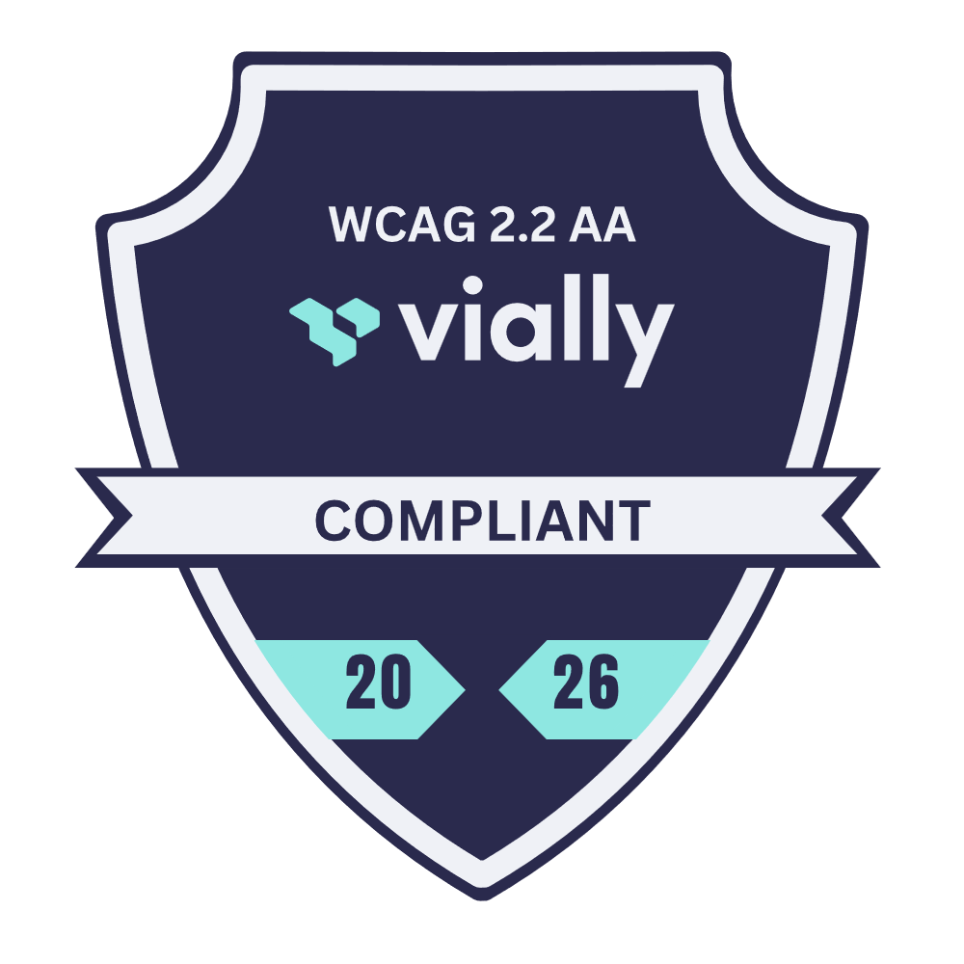

Accessible Content
Keyboard/Screen reader navigation is fully accessible on the website.
Skip to content link has been implemented.
Images – images have contextual alternative text.
Forms – all forms have accessible error validation and focus.
Link Text – we have removed links named ‘click here’ and ‘find out more’ where possible, links have also been given clear labels.
Correctly structured content with good heading usage – we have implemented logical heading structures throughout our pages.
Cross operating system compatibility – has been implemented in every section. CSS has also been updated for desktop and mobile.
Mobile navigation – along with cross operating system compatibility, we have implemented mobile navigation and ease of use for screen readers.
Third-party content – there are areas of our website controlled by third-party companies, such as the cookies. These are not funded by, developed, or controlled by Tullamore Credit Union, but we have resolved as many issues related to these areas as feasibly possible.

WCAG 2.2 Accessibility Auditing Service
If you would like your website, application or digital documents reviewed and tested against the WCAG 2.2 standards, please contact the Vially team at hello@vially.com.

