

Gender Pay Gap Reporting Tullamore Credit Union
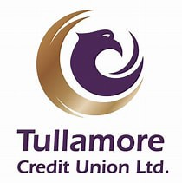

Contents
Company Overview 2
Timeline 2
The Data 3
Pay Gap 3
Detailed Pay and Variable Pay Data 4
Variable Pay Gap 4
Representation of women and different levels within the organisation 5
Benefit in Kind (BIK) 5
Gender Proportions in each salary quartile 6
Initiatives and Progress 6
Summary of Data/Data Findings 7
Summary of Key Figures 7
Ongoing Commitment and Actions 8
Looking Ahead 8

Company Overview
At Tullamore Credit Union, fairness and equality are core to our values. This Gender Pay Gap Report demonstrates our commitment to transparency and continuous improvement. We acknowledge the gaps identified and have set clear actions to address them. Our goal is to ensure that progress is measurable and sustainable, reinforcing our values of community and integrity.
Tullamore Credit Union Ltd was established in 1963. From the beginning, our members have been at the heart of everything we do – we are run by fellow voluntary members, elected to the Board of Directors and Oversight Committees.

Timeline

DATA COLLECTION DATE | June 2025
COMPLETION OF REPORT | 26th of November 2025
PUBLICATION OF REPORT | 28th of November 2025

This report will be published on Tullamore Credit Union’s website and remain publicly accessible for a minimum of three years, in compliance with the Gender Pay Gap Information Act 2021.





The Data
Figure 1: Overall Staff Representation
The data is based on all employees on the payroll as of the snapshot date (June 2025), including full-time, part-time, and temporary staff. Calculations follow the methodology outlined in the Gender Pay Gap Information Act 2021.
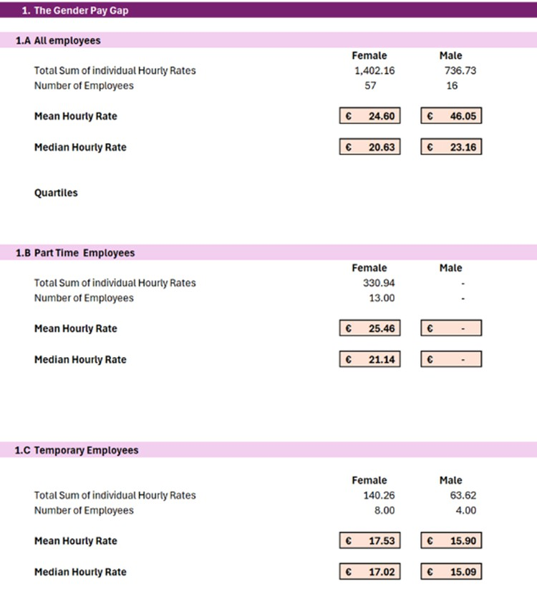

Pay Gap

Mean Hourly Rate: Men €46.05 vs Women €24.60. Median: Men €23.16 vs Women €20.63. Large gap driven by senior male roles.
Part-Time Employees: All part-time roles are held by women. Mean €25.46, Median €21.14. Temporary Employees: Female Mean €17.53 vs Male €15.90. Median: Female €17.02 vs Male
€15.09.

Detailed Pay and Variable Pay Data

Category | Men (€) | Women (€) | Observation
Mean Hourly Rate | 46.05 | 24.60 | Large gap due to senior male roles
Median Hourly Rate | 23.16 | 20.63 | Smaller gap, most  employees similar
Mean Variable Pay | 4,083.99 | 3,419.58 | Men dominate middle management roles
Median Variable Pay | 3,750 | 2,788.75 | Variable Pay eligibility  limited to management
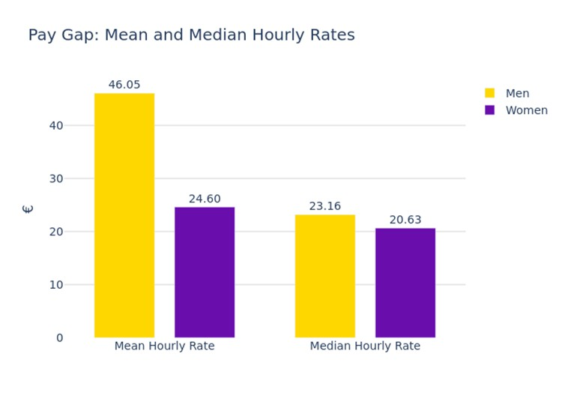

Variable Pay Gap

The analysis highlights a clear disparity in variable pay distribution and pay structure. The mean variable pay for men is €4,083.99 compared to €3,419.58 for women, while the median variable pay stands at €3,750 for men versus €2,788.75 for women. Variable Pay is payable to senior management roles and the variance reported is due to the differences in base salary by role and not by gender. Salary quartile data further illustrates structural imbalance: women dominate the lower quartiles (100% in the lowest and upper-middle quartiles, and 88.89% in the lower-middle quartile), whereas men hold the majority in the highest quartile (73.68%). This distribution shows that men are concentrated in the highest pay bands, while women are clustered in lower bands, reinforcing the overall gender pay gap.

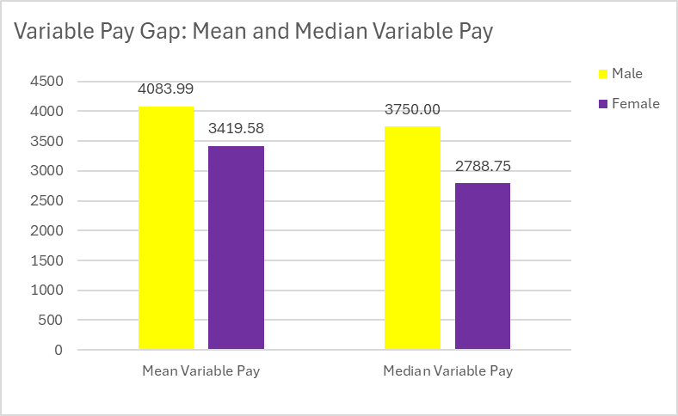

Representation of women and different levels within the organisation

Tullamore Credit Union demonstrates strong overall female representation, with women accounting for 78.1% of the workforce (57 women compared to 16 men). However, senior leadership remains male-dominated, with five of the seven full-time equivalent management positions held by men and
2.6 by women. Despite this imbalance, recent progress signals a strong positive momentum toward change. This shift has been particularly evident with the appointment of a dedicated HR Manager and a renewed focus on initiatives that promote gender balance and leadership development. Middle management roles have also seen improvement, with four controller positions now held by women two appointed this year and two last year indicating that targeted strategies are beginning to deliver results.

Benefit in Kind (BIK)

Benefit-in-Kind (BIK) analysis reveals a significant disparity between male and female employees. The results show that 13% of men received BIK compared to only 2% of women. There are only 3 members of staff receiving BIK, 2 of which have longstanding arrangements. There is only one senior role eligible for BIK and BIK is not eligible to any other staff member.

Gender Proportions in each salary quartile
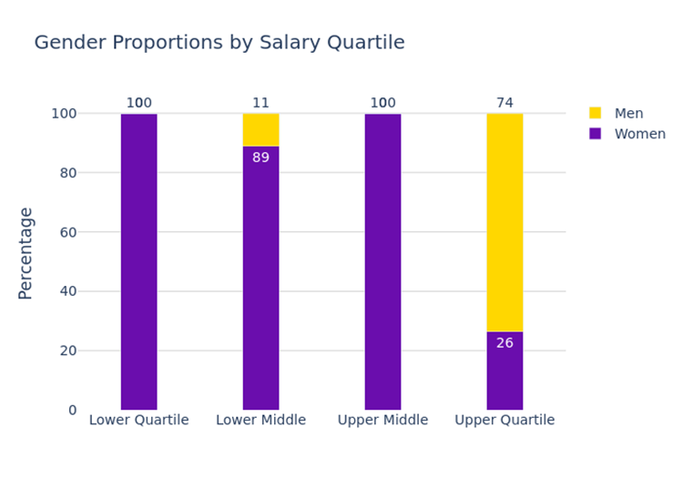
Women dominate the lower and middle quartiles, accounting for 100% of employees in both the lowest and upper-middle quartiles and 88.89% in the lower-middle quartile. In contrast, men hold the majority in the highest quartile, representing 73.68% of employees, while women make up only 26.32%. This pattern indicates that men are concentrated in the highest-paid roles, while women are clustered in lower pay bands. Such distribution is a key driver of the overall gender pay gap, as senior positions with higher salaries and variable pay eligibility remain predominantly male. Addressing this imbalance through targeted leadership development, succession planning, and flexible senior role opportunities will be critical to reducing the gap over time.

Initiatives and Progress
- Leadership Development: Strengthened leadership team with the appointment of a Deputy CEO and HR Manager to drive equality and succession planning. Caroline Collins-Murphy’s appointment as Deputy CEO and her active role in community initiatives reflect this commitment.
- Community Engagement: Through the Community Support Fund, €100,000 was distributed to over 120 local groups, supporting education, sports, and environmental projects. Initiatives like “Pride in Your Place” and “Raise Your Voice” community quiz further demonstrate engagement.
- ESG and Strategic Actions: The Credit Union’s strategic plan includes measures under Environmental, Social, and Governance (ESG), focusing on diversity, inclusion, and community impact.
-Tullamore Credit Union promotes a positive work-life balance through flexible working arrangements, including part-time patterns. These measures support employees in balancing professional and personal commitments and contribute to an inclusive workplace culture.

Summary of Data/Data Findings
Representation
The company has strong overall female representation, with 57 women compared to 16 men across all roles. However, senior management remains male-dominated, with five of seven full-time equivalent management positions held by men and 2.6 by women. Despite this imbalance, significant progress has been made in recent years. Three senior roles Deputy CEO, HR Manager, and Solicitor were filled by women in the past couples of years, and four controller positions are now held by women, two appointed this year and two last year. The appointment of Caroline Collins-Murphy as Deputy CEO and her election as President of the local Chamber of Commerce further demonstrates leadership advancement and commitment to change.
Pay Gap
The mean hourly rate for men (€46.05) is substantially higher than for women (€24.60), driven by the concentration of men in senior roles. The median gap is smaller (€23.16 for men vs €20.63 for women), indicating that most employees earn similar rates, but a few high-paid male roles skew the mean.
Part-Time and Temporary Roles
All part-time roles are held by women, with a mean hourly rate of €25.46, slightly higher than the overall female mean, but these roles often lack progression opportunities. Temporary roles show women earning slightly more than men (€17.53 vs €15.90), though these positions have the lowest pay overall.
Variable Pay Gap and Benefits
Variable Pay is concentrated among management roles, where men are overrepresented. The mean variable pay for men (€4,083.99) exceeds that for women (€3,419.58), and variable pay eligibility is 31% for men versus 5% for women. Variable Pay is only payable to senior roles and is equal across both genders. The variance reported is due to differences in base salary by role and not eligibility or percentage.
Quartile Distribution
Women dominate the lower and middle quartiles (100% in the lowest and upper-middle quartiles, and 88.89% in the lower-middle quartile), while men hold the majority in the highest quartile (73.68%). This structural imbalance reinforces the overall pay gap.

Summary of Key Figures
Metric | Men (€) | Women (€)
Mean Hourly Rate | 46.05 | 24.60
Median Hourly Rate | 23.16 | 20.63
Mean Variable Pay | 4,083.99 | 3,419.58
Median Variable Pay | 3,750 | 2,788.75
Benefit-in-Kind % | 13% | 2%

Ongoing Commitment and Actions
Tullamore Credit Union is committed to promoting fairness and equality. Tullamore Credit Union will continue to monitor gender representation and pay trends, taking practical steps to support progress. Key priorities include encouraging female participation in senior roles, maintaining flexible working options, and reviewing benefit structures for transparency. In 2025, all employees completed Dignity and Respect training delivered by NFP HR Solutions, reinforcing our commitment to fostering an inclusive and respectful workplace culture.

Looking Ahead
Tullamore Credit Union will continue to take measured, achievable actions to reduce the gender pay gap while maintaining transparency and fairness.
Our measurable goals:
  - Continued efforts to increase female representation in senior management by the end of next year.
  - Introduce a leadership development program for high-potential female employees by Q2 2026.
  - Maintain flexible working options and monitor uptake quarterly.
  - Publish annual gender pay gap updates to track progress.
  - Tullamore Credit Union will also provide training to support inclusive practices.

