Dear member,
As you may already be aware, new legislation will come into effect on 14th September 2019 called the Payment Services Directive (PSD2). Part of this legislation requires enhanced security when it comes to managing your finances online.
What does this mean to you?
It simply means enhanced security steps have been added to give you peace of mind. Changes have been made to how you will log in and how you will set up/amend a payment.
Account Access
Existing cuOnline+ members
There will be an additional level of security that you must enter in order to be able to access your account. Please note that you will only need to enter your PIN once to activate the new security login following which the PIN will no longer be required as a new 3 step process must now be followed:

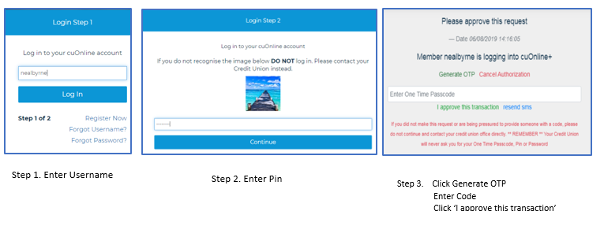
Step 2. Enter Password

New cuOnline+ members: first time access
There will an additional one-time activation security step for members accessing their accounts for the first time as follows.
- Enter username Click login
- Enter password Click continue

- Generate OTP Click Generate OTP – You will receive a secure SMS
The code within the SMS must be entered at this point
Click I approve this transaction

- Enter activation PIN Click submit

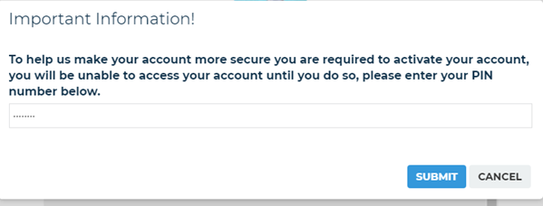

Once you have established your online access, you can speed up your login process by using the cuAnywhere app to scan the QR code and use your fingerprint or facial recognition to login automatically

Setting up a new payee
If a you wish to set up a new payee within cuOnline+ a new additional security step will be required. You will need to ‘Generate OTP’

- Click on Payments option on left hand side

- Click on ‘Manage Payees’ button

- Navigate to ‘Set up a new payee’ and click next
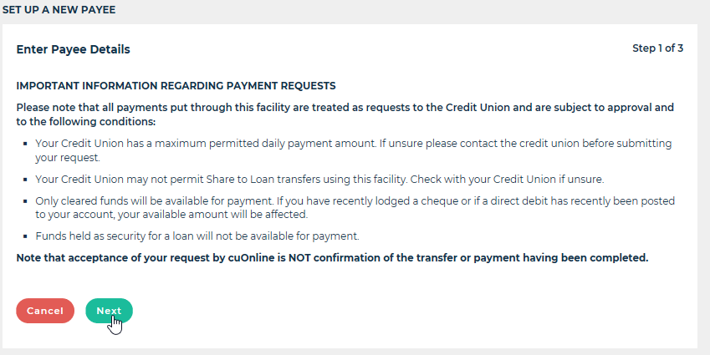

- Enter the new payees banking details, then click next
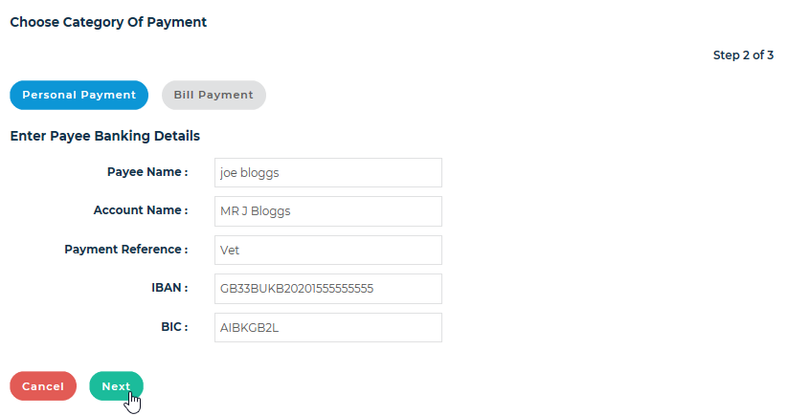

- Enter your password, then click confirm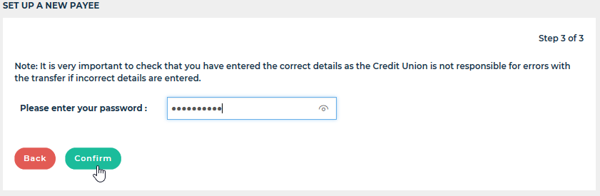

- Generate the OTP, enter the code, then click approve transaction to set up the new payee.
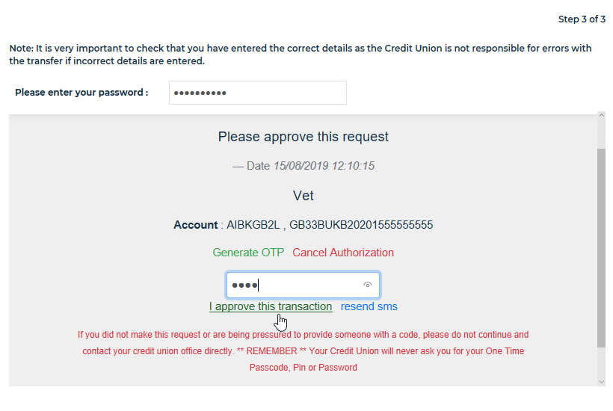

Adding/amending a recurring payment
If you wish to add/amend a recurring payment within cuOnline+ a similar additional security step will be required. You will need to ‘Generate OTP’

- Click on Payments option on left hand side

- Click on ‘My regular Payments’ button

- Make changes by clicking the edit icon

- Enter changes and click on generate One Time Passcode, Enter Code, click submit

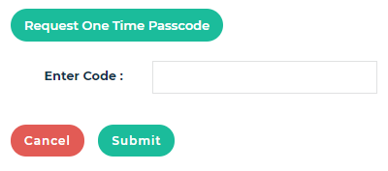

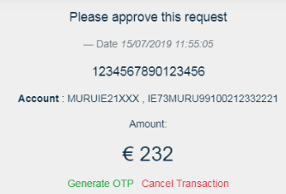

If you have any further questions around PSD2, please feel free to call your local branch and speak to one of our advisors.
Kind regards.
Your Credit Union.

